Week In Review September 5 - September 12, 2001
Alex Shvartsman

Terrorist Attack in New York

As all of you undoubtedly know, New York was assaulted by terrorists on Tuesday morning. As a result, countless lives were lost, New York skyline is missing its most prominent fixture, and the city is still trying to recover from the state of chaos. This heinous crime took place only two days after Pro Tour-New York, causing the Magic community to be concerned over the fate of the PT-NY attendees still in the city.
I spent most of Tuesday on the phone, helping locate friends and family members of those people I could talk to on IRC (inter-city phone communications were not working very well - a huge number of calls overloaded the circuits). With combined efforts of players on Efnet IRC channels #mtg and #mtgwacky, we are happy to report that most Magic players who are currently in New York were located and are safe. Here is some of the information we've been able to put together.
- Wizards of the Coast employees still in NYC were all contacted and accounted for, according to Scott Larabee and Thomas Pannell.
- Magic players who live in NYC (Zvi Mowshowitz, Mike Pustilnik, Dave Price, Eric Kesselman, etc.) are accounted for. There are no apartment buildings near the World Trade Center, so those who were at home at the time of the incident were unharmed.
- Victor Van der Broek and Jelger Wiersma were among about a dozen Magic players who were still in NYC, planning to sightsee on Tuesday. Victor and his friends were planning to head over to WTC after breakfast. Fortunately for them, and other tourists, WTC does not open to tourists till 9:30am.
- Dan Clegg and his teammates Lan and Ken Ho were on their way home, having left NYC at 6 am. Their plane was grounded like so many others, and they will be forced to spend some more time in a hotel room until flights resume.
- I was among many New Yorkers who barely dodged tragedy in their homes. My mother works at WTC. Fortunately, she was late for work on Tuesday. The bus she was on was en route to downtown Manhattan when the first plane crashed into the World Trade Center. The bus was never allowed to enter Manhattan and she returned home safely.
- Of all Magic players, Chris Pikula was probably the one in most danger. He works on the floor of the NY Stock Exchange and was only blocks away from the World Trade Center when it was hit. Like many others, he was forced to take a long walk uptown in order to get out of the area. He got home safely.
Like so many others, the Magic community is banding together to help victims deal with the consequences of attacks in New York and Washington. Ray Powers's store in Arizona offered free drafts to any player who gave blood on Tuesday. I encourage other store owners to find similar ways to help out.
If the planes are still grounded by the time this column is released, and you know players who are still in NY and need a place to stay for a few days, please feel free to contact me at ashv80@hotmail.com; my house can accommodate several people.

Pro Tour-New York
Is Kai the next Finkel, or was Finkel simply a prelude to Kai?
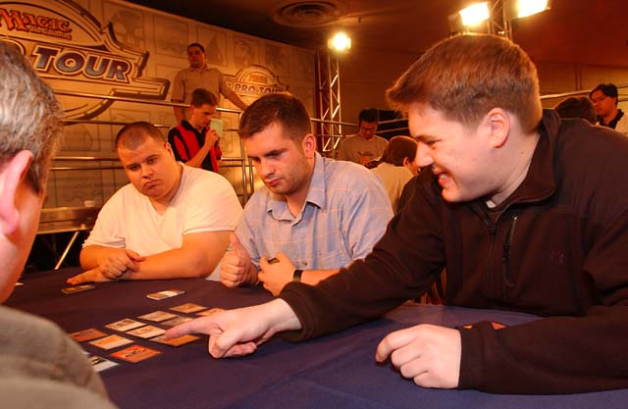
Kai Budde showed that he could win across formats. Although he could put together almost any team from the pool of the Pro Tour regulars (who would say no?), Budde chose to bring two of his good friends out of retirement. Marco Blume is a one-time German National Champion who has not seen much success on the Pro Tour. This gentle giant is nevertheless a very solid player who got the break he needed to succeed this weekend. Kai's other teammate is Dirk Baberowski. Baberowski is one of the finest players in the game, despite his love/hate relationship with Magic. He won his very first Pro Tour-Chicago several years ago, and went on to enjoy success both on Pro Tour and Grand Prix circuits. Baberowski often threatened to quit pro Magic though, and finally made good on the threat and has been off the Pro Tour for about a year. He currently owns a travel agency in Cologne and remains in touch with his friends in Magic community. Kai Budde dragged these two out of retirement, whipped them into shape, and won his fourth Pro Tour - an amazing accomplishment, from an amazing player.
A total of approximately 150 teams registered to play at the Garden that weekend. Wizards of the Coast, concerned that the registration numbers might be even higher, announced that any team with 15 points (5-2 record or better) would advance to Day 2. This is replacing the old system where Top 20 teams in the standings advanced. The change allowed nine extra teams to play on Day 2, including the eventual finalists Les Plus Class. This system was much applauded by players, who prefer not to be shut out of Day 2 on tiebreakers.
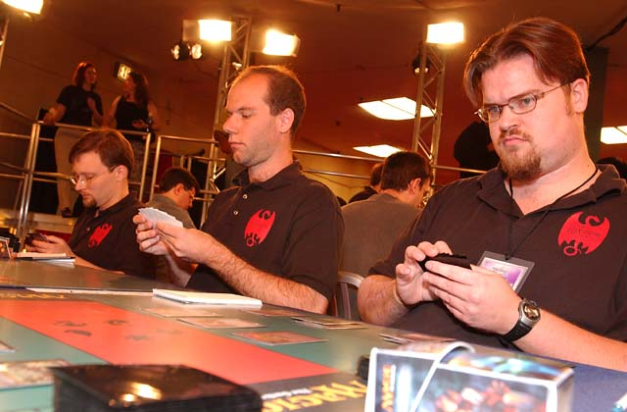
Despite making it just a little easier to enter Day 2, many of the highest-profile teams missed the cut. Among these were Black Ops, Potato Nation, Antarctica, and Your Move Games. Your Move Games were the talk of Day 1, as they dropped out at the 1-1-1 record. "We must protect our rating for Masters," explained Rob Dougherty. "The chances of us going 4-0 in a sealed deck format are low enough where it was better for us to drop out of the tournament." Critics believe the team should have played with a different roster at PT-NY, thus protecting the rating of the original trio and still able to compete for an entire day. The only undefeated team at the end of Day 1, was my own My Team, Part 17 (Gary, Mowshowitz, Shvartsman). The name referred to Zvi's lengthy Sideboard series "My Fires", but many players found a second meaning - each of us played on many different teams before coming together for this weekend. We beat team Metagames (Raphael Levy and Franck Canu) in the final round to earn the lead. Local players did extremely well overall. Seven Neutral Ground teams made Day 2.
Day 2 featured a total of five Rochester drafts, where teams competed for the coveted Top 4 positions. My Team (later renamed to Illuminati) stayed in the lead all the way through, intentionally drawing in the final round. Phoenix Foundation (Kai's team) was the only one to defeat us all day and came in second after Day 2. Les Plus Class, a relatively unknown French team was the definite underdog of the Top 4, rounded off by last year's finalist Car Acrobatic Team. The two European teams met in the finals, and the rest is history. Budde has upped the number of Pro Tours won to four, though he is still almost $100,000 behind Finkel in lifetime winnings. Kamiel Cornelissen, considered by many the only other player in contention for the "world's best" moniker did not disappoint either, his team finishing seventh.
As usual, a team event is a showcase of players' creativity when it comes to team names. My favorites for the weekend were "Stalking Tiger, Hidden Gibbons" and "Fellowship of the Ting".

Magic Trivia
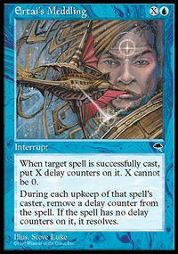
Last week's Question:
This excellent question is brought to you courtesy of Andrew Levine:
How is it possible to attack your opponent BEFORE the first main phase of the turn? This isn't a trick question; there really is a combination of cards that lets you attack before you've had a main phase.
Answer: Cast Ertai's Meddling on Relentless Assault. Once an appropriate number of turns passes, the Assault will resolve during upkeep prompting the next step (prior to the first main phase) to be an attack step.
New question:
Who invented the 5-Color format to be used at the Magic Invitational next month?
Please do not email me your answers. The correct answer will be posted in next week's column.

Bad Play of the Week
Sometimes you do not make a bad play - it just happens to you. I would like to present two such examples here. First is reported by James Marden:
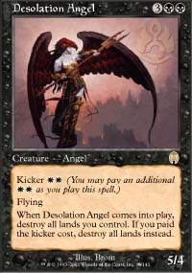
"I was recently at a Standard tournament and I witnessed one very interesting and extremely humiliating play. The matchup consisted of a white-blue control versus black-white control. One player decided to cast Bribery. Little did he know that the only creature in his opponent's deck was Desolation Angel! Unable to pay the kicker (Bribery doesn't allow it) He looked at all his lands, looked back at the Angel and simply shook his head. To make matters worse, his opponent followed up with a Vindicate to seal the win."
A second, similar play is reported by Paul Jordan and happened at the Pro Tour. Paul's board position was looking very grim, as he was facing down an army of green creatures, only a turn or two away from the game ending. His opponent decided to drive the nail into the coffin by casting Thicket Elemental with kicker. It resolved, he flipped over several non-creature cards, and then found... Desolation Giant! Since he did not have the option of paying kicker, the Giant took out his entire army, allowing Jordan to make a comeback and win the game.
As always, please send good/bad plays, cool trivia questions, and other news to NEW ADDRESS: ashv80@hotmail.com.

